Ecolab – RAG + Tool Calling Agent
Step 1 – Launch the app (streamlit run app.py)

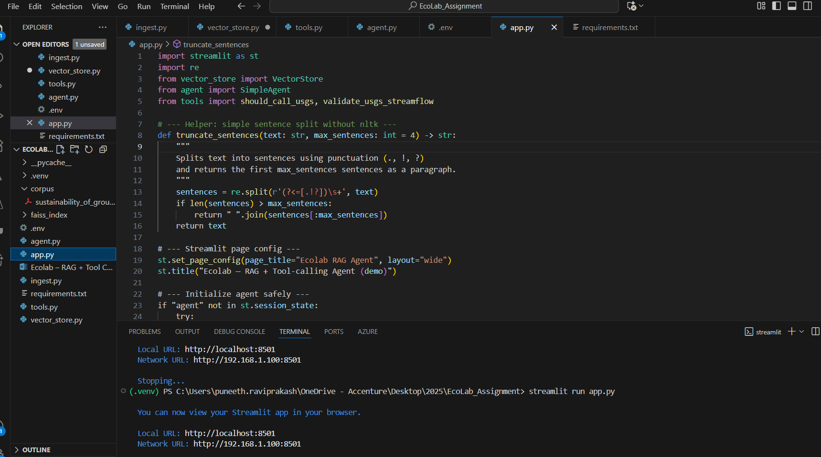

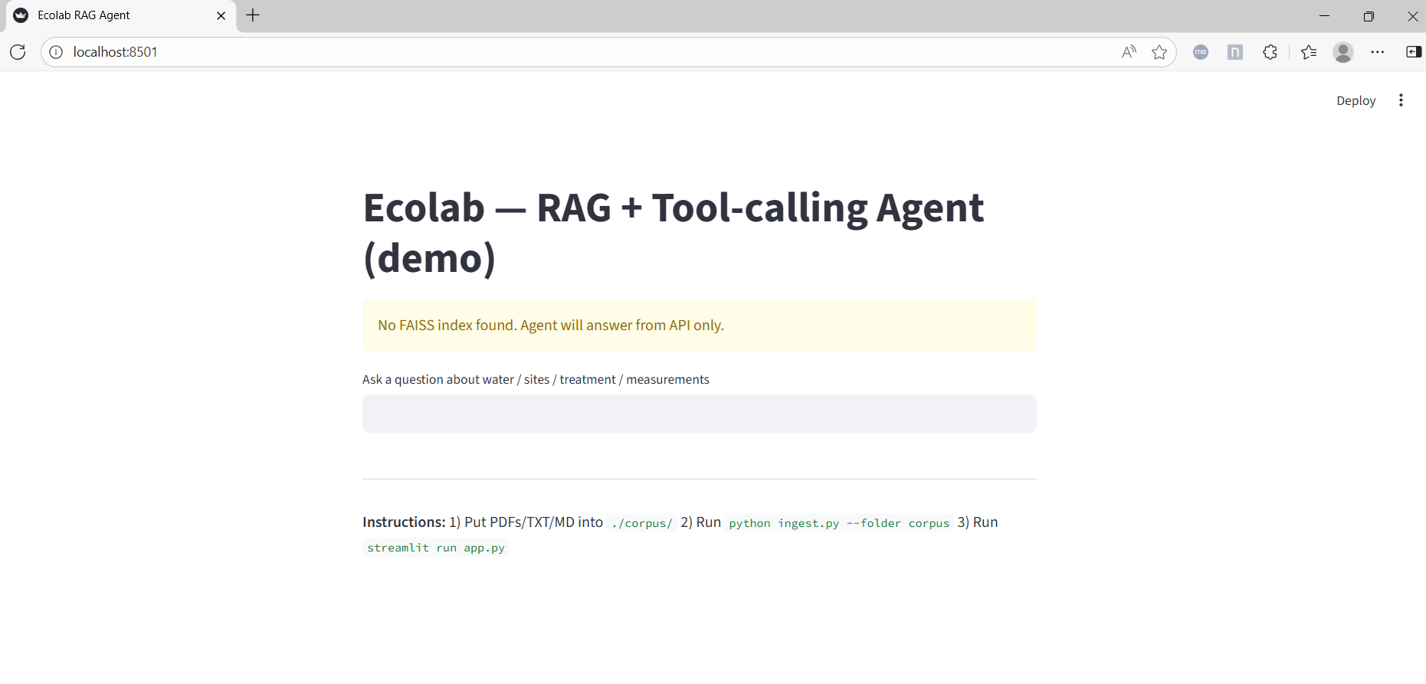
Step 2 – Enter the question from API (https://waterservices.usgs.gov/nwis/iv/?format=json&sites=01646500&parameterCd=00060
) –
What is the streamflow at site 01646500?
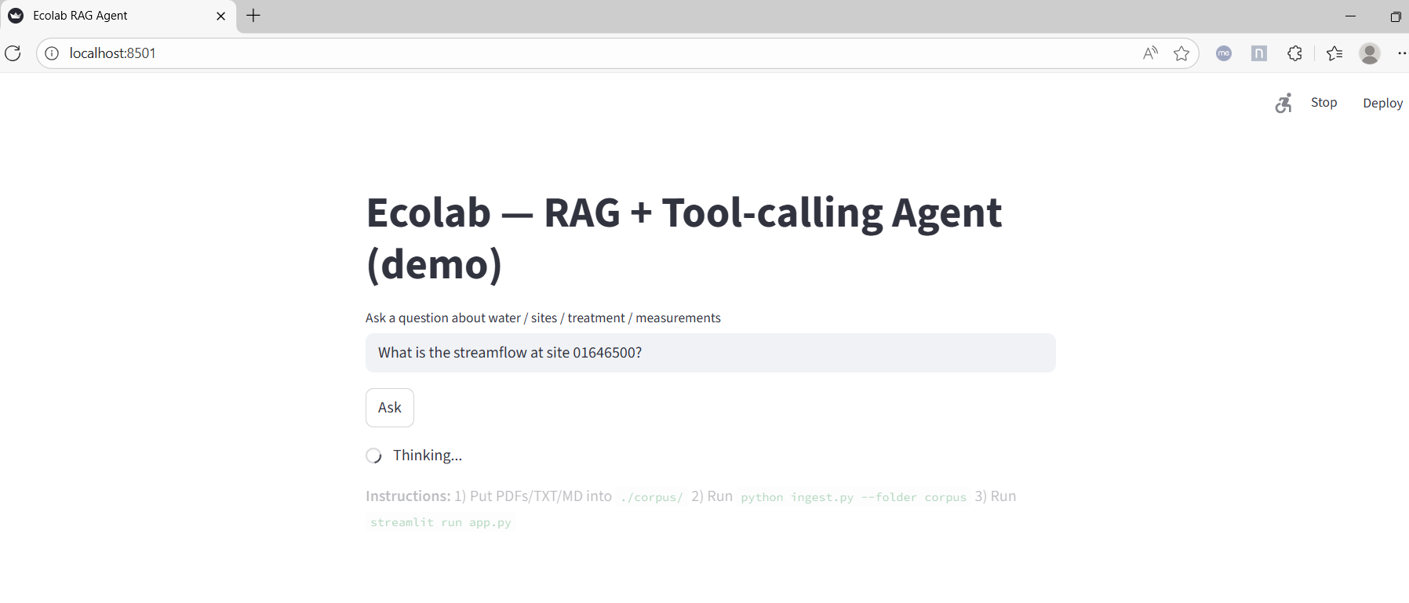
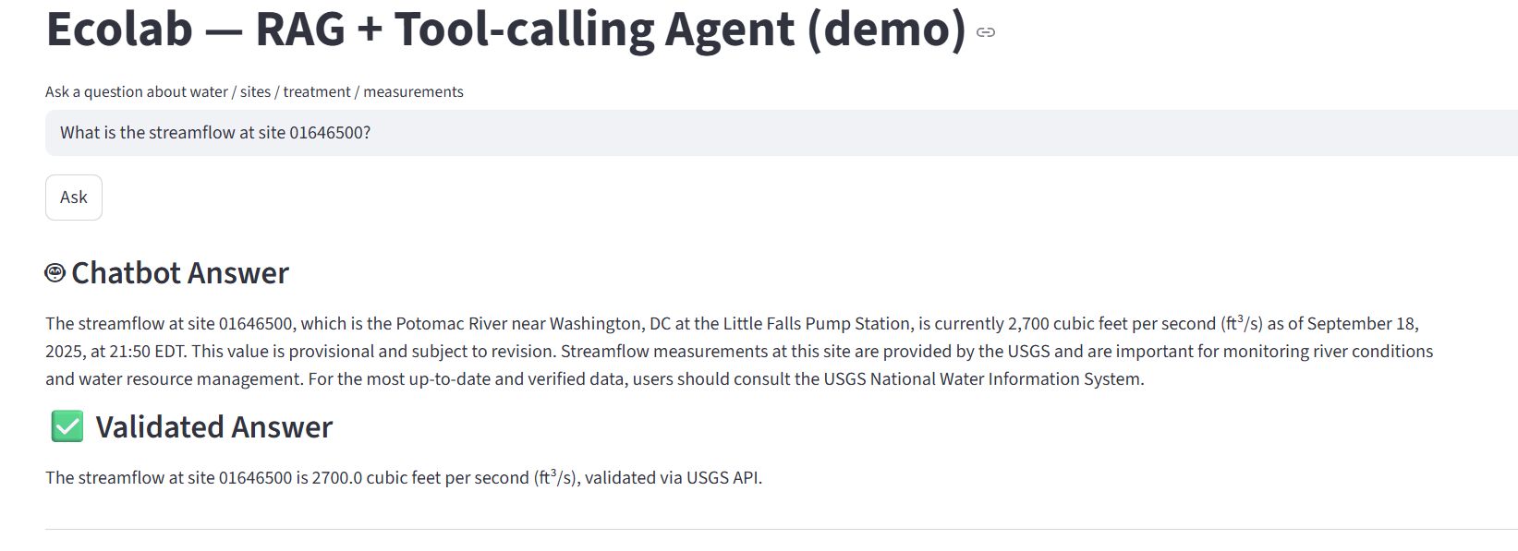

*******Note******* The following 3 questions were asked from the loaded pdf (sustainability_of_ground_water_resources.pdf). LLM Agent will respond only from created embeddings in faiss vector db.
Step 3 – you would be able to see LLM response (Chatbot Answer) and the actual raw response (Validated Answer) from USGS site. Raw and LLM (Azure ChatGPT) response is as expected.
Question 1 -
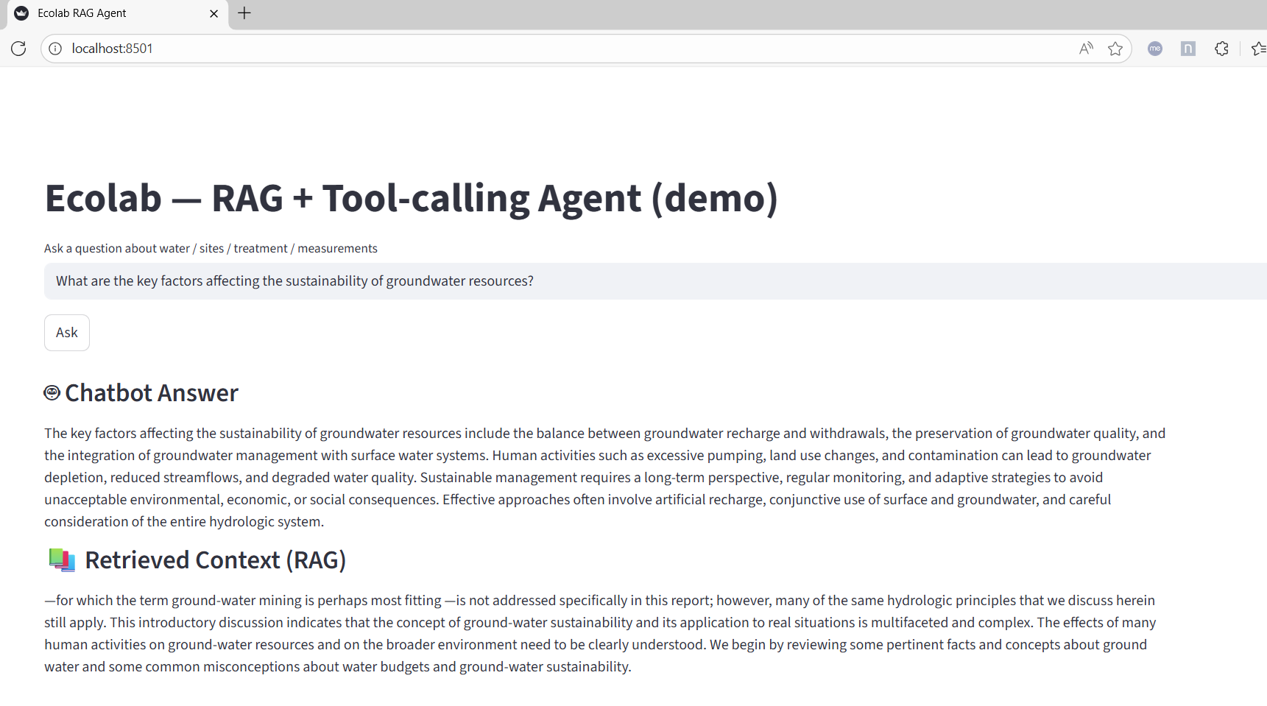
Question 2 (from the loaded pdf) - What challenges arise from groundwater over-extraction?
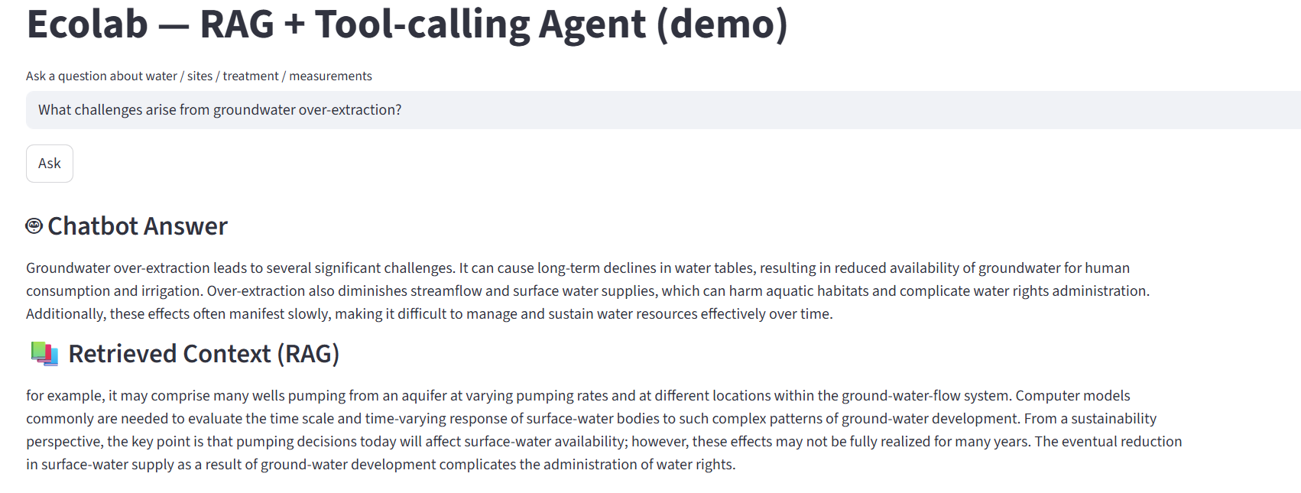
Question 3 - How does climate change influence groundwater resources?
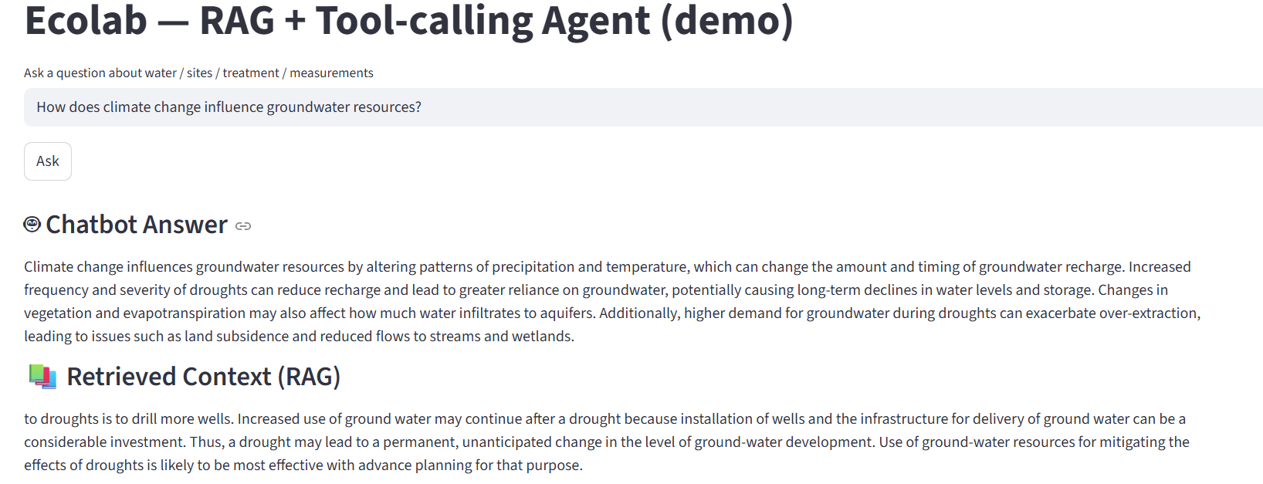
Question 4 - What role do local communities play in groundwater resource management?
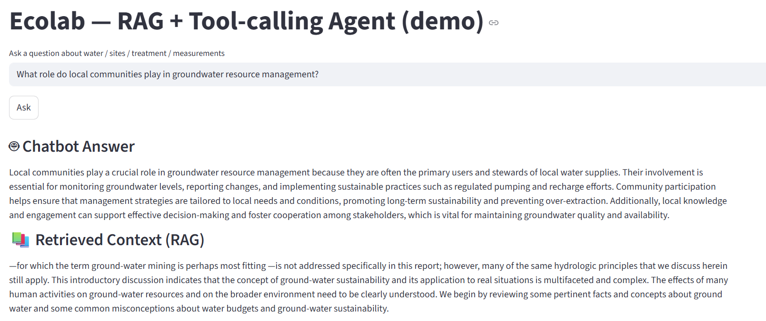

RAG Evaluation – Rouge Score
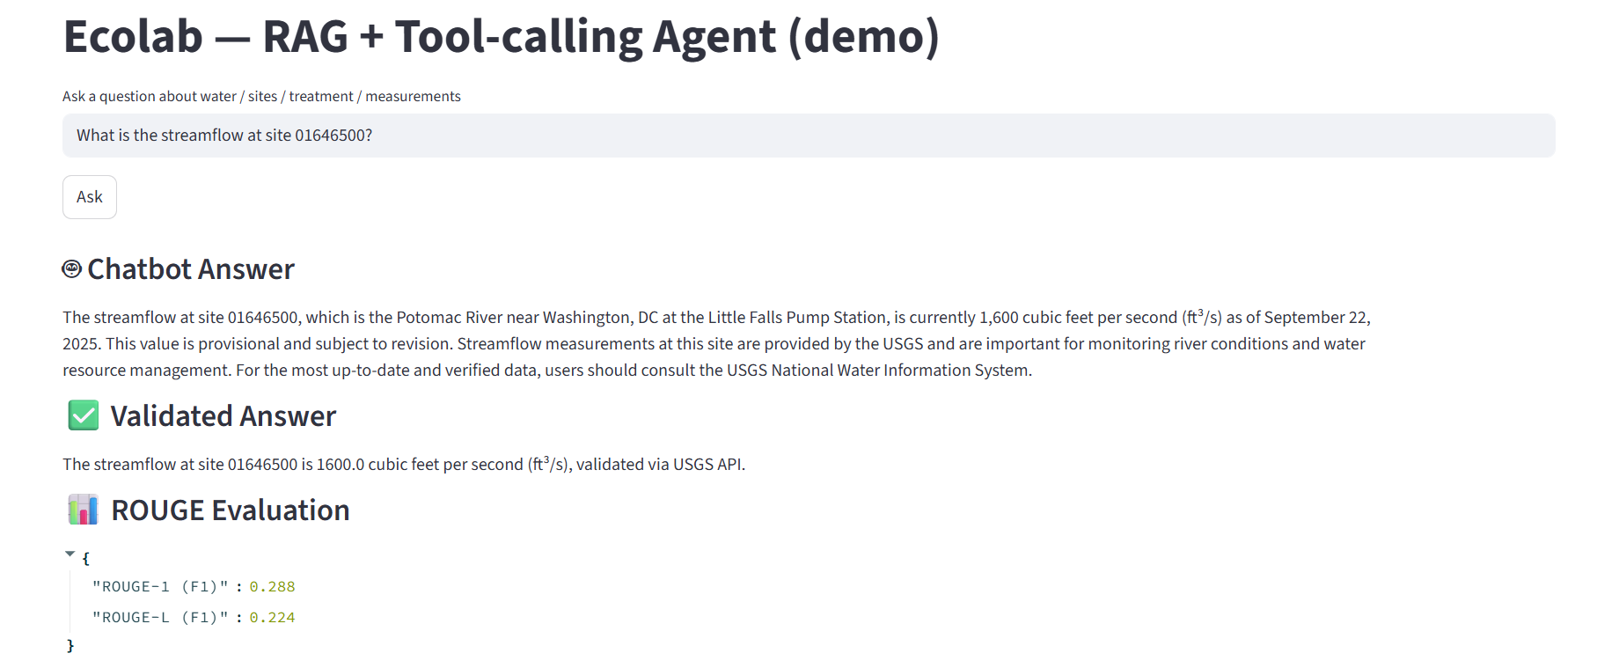

ROUGE compares exact words/sequences, not meaning. Even if your chatbot answer is factually correct but phrased differently, ROUGE will penalize it.
ROUGE-1 (F1)
- Measures overlap of individual words (unigrams) between the chatbot answer and the validated answer.
- Example:
  - Reference: "streamflow is 1600 cubic feet per second"
  - Generated: "streamflow measured at 1600 ft³/s"
  - Common unigrams = {streamflow, 1600} → this contributes to ROUGE-1.
So ROUGE-1 tells you how much of the exact word-level information overlaps.

🔹 ROUGE-L (F1)
- Measures the Longest Common Subsequence (LCS) between reference and generated text.
- It’s less about word-by-word matches and more about capturing sequence structure and sentence fluency.
- Example:
  - Reference: "The streamflow at site 01646500 is 1600 cubic feet per second"
  - Generated: "The streamflow is 1600 cubic feet per second at site 01646500"
  - Many words match, but in slightly different order → ROUGE-L captures that.
So ROUGE-L tells you how well the generated answer preserves sentence structure and phrasing similar to the ground truth.
in Rouge-L(F1) - If your chatbot generates a longer explanation than the reference, precision drops. If it generates a shorter summary, recall drops. Since F1 balances both, the score ends up low.
How Rouge works ??
What is ROUGE-1?
ROUGE-1 measures overlap of unigrams (single words) between a reference text (ground truth) and a candidate text (chatbot answer).
It computes:
- Recall = How many words from the reference are also in the candidate.
- Precision = How many words from the candidate are also in the reference.
- F1 = Balance between precision and recall.

🔹 Formula
Given:
- Reference text = R
- Candidate text = C
- Overlap = number of unigrams common to both
Recall=∣Overlap∣∣Reference unigrams∣\text{Recall} = \frac{|\text{Overlap}|}{|\text{Reference unigrams}|}Recall=∣Reference unigrams∣∣Overlap∣​ Precision=∣Overlap∣∣Candidate unigrams∣\text{Precision} = \frac{|\text{Overlap}|}{|\text{Candidate unigrams}|}Precision=∣Candidate unigrams∣∣Overlap∣​ F1=2×Precision×RecallPrecision+Recall\text{F1} = \frac{2 \times \text{Precision} \times \text{Recall}}{\text{Precision} + \text{Recall}}F1=Precision+Recall2×Precision×Recall​

🔹 Example
Reference:
the streamflow is 1600 cubic feet per second
Candidate:
streamflow at site is 1600 ft³ per second
Step 1: Tokenize
- Reference unigrams = [the, streamflow, is, 1600, cubic, feet, per, second] → 8 tokens
- Candidate unigrams = [streamflow, at, site, is, 1600, ft³, per, second] → 8 tokens
Step 2: Find Overlap
Common tokens = [streamflow, is, 1600, per, second] → 5 overlaps
Step 3: Compute
- Recall = 5 / 8 = 0.625
- Precision = 5 / 8 = 0.625
- F1 = 2 × (0.625 × 0.625) / (0.625 + 0.625) = 0.625
👉 ROUGE-1 (F1) = 0.625

Applied Rouge and BERTScore for evaluation
